**Secret-Key Encryption Lab**

**——57118125施祺**

**Task 1: Frequency Analysis Against Monoalphabetic Substitution Cipher**

将文本复制到计算频率的网站

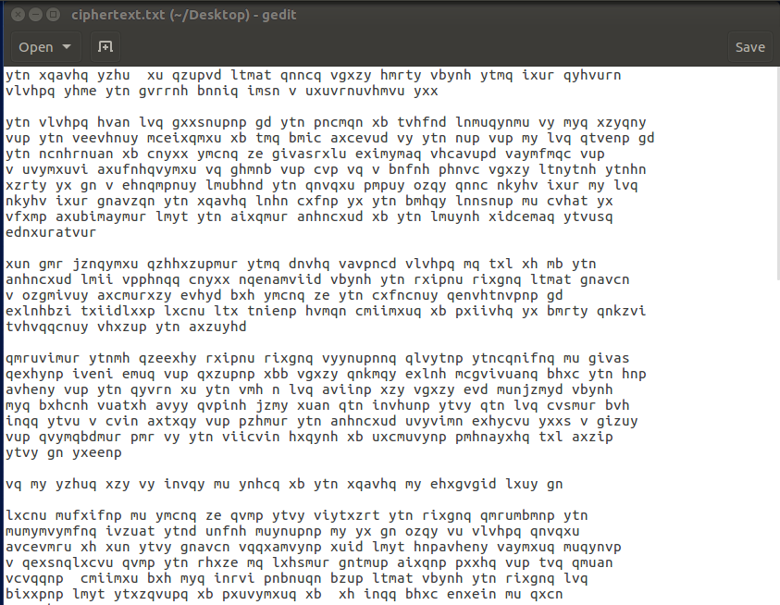

单字母频率测试如下

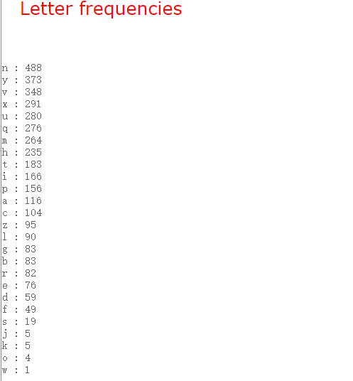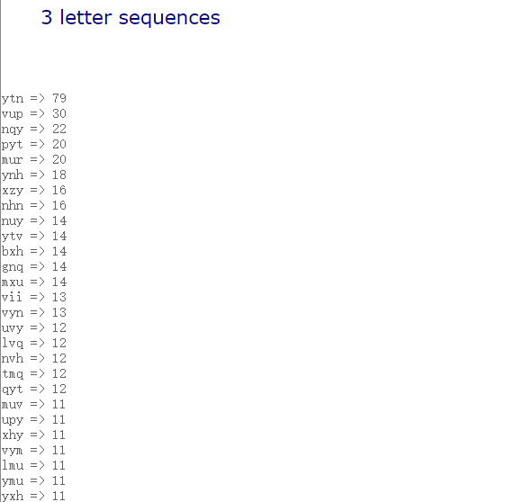

通过逐一比对，猜测，最终找出配对的明文密文。成功翻译，翻译结果如下：



明文为：

THE OSCARS TURN ON SUNDAY WHICH SEEMS ABOUT RIGHT AFTER THIS LONG STRANGE AWARDS TRIP THE BAGGER FEELS LIKE A NONAGENARIAN TOO

THE AWARDS RACE WAS BOOKENDED BY THE DEMISE OF HARVEY WEINSTEIN AT ITS OUTSET AND THE APPARENT IMPLOSION OF HIS FILM COMPANY AT THE END AND IT WAS SHAPED BY THE EMERGENCE OF METOO TIMES UP BLACKGOWN POLITICS ARMCANDY ACTIVISM AND A NATIONAL CONVERSATION AS BRIEF AND MAD AS A FEVER DREAM ABOUT WHETHER THERE OUGHT TO BE A PRESIDENT WINFREY THE SEASON DIDNT JUST SEEM EXTRA LONG IT WAS EXTRA LONG BECAUSE THE OSCARS WERE MOVED TO THE FIRST WEEKEND IN MARCH TO

AVOID CONFLICTING WITH THE CLOSING CEREMONY OF THE WINTER OLYMPICS THANKS PYEONGCHANG

ONE BIG QUESTION SURROUNDING THIS YEARS ACADEMY AWARDS IS HOW OR IF THE

CEREMONY WILL ADDRESS METOO ESPECIALLY AFTER THE GOLDEN GLOBES WHICH BECAME A JUBILANT COMINGOUT PARTY FOR TIMES UP THE MOVEMENT SPEARHEADED BY POWERFUL HOLLYWOOD WOMEN WHO HELPED RAISE MILLIONS OF DOLLARS TO FIGHT SEXUAL HARASSMENT AROUND THE COUNTRY

SIGNALING THEIR SUPPORT GOLDEN GLOBES ATTENDEES SWATHED THEMSELVES IN BLACK SPORTED LAPEL PINS AND SOUNDED OFF ABOUT SEXIST POWER IMBALANCES FROM THE RED CARPET AND THE STAGE ON THE AIR E WAS CALLED OUT ABOUT PAY INEQUITY AFTER ITS FORMER ANCHOR CATT SADLER QUIT ONCE SHE LEARNED THAT SHE WAS MAKING FAR LESS THAN A MALE COHOST AND DURING THE CEREMONY NATALIE PORTMAN TOOK A BLUNT AND SATISFYING DIG AT THE ALLMALE ROSTER OF NOMINATED DIRECTORS HOW COULD THAT BE TOPPED

AS IT TURNS OUT AT LEAST IN TERMS OF THE OSCARS IT PROBABLY WONT BE

WOMEN INVOLVED IN TIMES UP SAID THAT ALTHOUGH THE GLOBES SIGNIFIED THE

INITIATIVES LAUNCH THEY NEVER INTENDED IT TO BE JUST AN AWARDS SEASON

CAMPAIGN OR ONE THAT BECAME ASSOCIATED ONLY WITH REDCARPET ACTIONS INSTEAD A SPOKESWOMAN SAID THE GROUP IS WORKING BEHIND CLOSED DOORS AND HAS SINCE AMASSED MILLION FOR ITS LEGAL DEFENSE FUND WHICH AFTER THE GLOBES WAS FLOODED WITH THOUSANDS OF DONATIONS OF OR LESS FROM PEOPLE IN SOME

COUNTRIES NO CALL TO WEAR BLACK GOWNS WENT OUT IN ADVANCE OF THE OSCARS THOUGH THE MOVEMENT WILL ALMOST CERTAINLY BE REFERENCED BEFORE AND DURING THE CEREMONY ESPECIALLY SINCE VOCAL METOO SUPPORTERS LIKE ASHLEY JUDD LAURA DERN AND NICOLE KIDMAN ARE SCHEDULED PRESENTERS

ANOTHER FEATURE OF THIS SEASON NO ONE REALLY KNOWS WHO IS GOING TO WIN BEST

PICTURE ARGUABLY THIS HAPPENS A LOT OF THE TIME INARGUABLY THE NAILBITER

NARRATIVE ONLY SERVES THE AWARDS HYPE MACHINE BUT OFTEN THE PEOPLE FORECASTING

THE RACE SOCALLED OSCAROLOGISTS CAN MAKE ONLY EDUCATED GUESSES

THE WAY THE ACADEMY TABULATES THE BIG WINNER DOESNT HELP IN EVERY OTHER

CATEGORY THE NOMINEE WITH THE MOST VOTES WINS BUT IN THE BEST PICTURE

CATEGORY VOTERS ARE ASKED TO LIST THEIR TOP MOVIES IN PREFERENTIAL ORDER IF A

MOVIE GETS MORE THAN PERCENT OF THE FIRSTPLACE VOTES IT WINS WHEN NO

MOVIE MANAGES THAT THE ONE WITH THE FEWEST FIRSTPLACE VOTES IS ELIMINATED AND ITS VOTES ARE REDISTRIBUTED TO THE MOVIES THAT GARNERED THE ELIMINATED BALLOTS SECONDPLACE VOTES AND THIS CONTINUES UNTIL A WINNER EMERGES

IT IS ALL TERRIBLY CONFUSING BUT APPARENTLY THE CONSENSUS FAVORITE COMES OUT AHEAD IN THE END THIS MEANS THAT ENDOFSEASON AWARDS CHATTER INVARIABLY INVOLVES TORTURED SPECULATION ABOUT WHICH FILM WOULD MOST LIKELY BE VOTERS SECOND OR THIRD FAVORITE AND THEN EQUALLY TORTURED CONCLUSIONS ABOUT WHICH FILM MIGHT PREVAIL

IN IT WAS A TOSSUP BETWEEN BOYHOOD AND THE EVENTUAL WINNER BIRDMAN

IN WITH LOTS OF EXPERTS BETTING ON THE REVENANT OR THE BIG SHORT THE

PRIZE WENT TO SPOTLIGHT LAST YEAR NEARLY ALL THE FORECASTERS DECLARED LA

LA LAND THE PRESUMPTIVE WINNER AND FOR TWO AND A HALF MINUTES THEY WERE

CORRECT BEFORE AN ENVELOPE SNAFU WAS REVEALED AND THE RIGHTFUL WINNER

MOONLIGHT WAS CROWNED

THIS YEAR AWARDS WATCHERS ARE UNEQUALLY DIVIDED BETWEEN THREE BILLBOARDS

OUTSIDE EBBING MISSOURI THE FAVORITE AND THE SHAPE OF WATER WHICH IS

THE BAGGERS PREDICTION WITH A FEW FORECASTING A HAIL MARY WIN FOR GET OUT

BUT ALL OF THOSE FILMS HAVE HISTORICAL OSCARVOTING PATTERNS AGAINST THEM THE SHAPE OF WATER HAS NOMINATIONS MORE THAN ANY OTHER FILM AND WAS ALSO NAMED THE YEARS BEST BY THE PRODUCERS AND DIRECTORS GUILDS YET IT WAS NOT NOMINATED FOR A SCREEN ACTORS GUILD AWARD FOR BEST ENSEMBLE AND NO FILM HAS WON BEST PICTURE WITHOUT PREVIOUSLY LANDING AT LEAST THE ACTORS NOMINATION

SINCE BRAVEHEART IN THIS YEAR THE BEST ENSEMBLE SAG ENDED UP GOING TO

THREE BILLBOARDS WHICH IS SIGNIFICANT BECAUSE ACTORS MAKE UP THE ACADEMYS

LARGEST BRANCH THAT FILM WHILE DIVISIVE ALSO WON THE BEST DRAMA GOLDEN GLOBE

AND THE BAFTA BUT ITS FILMMAKER MARTIN MCDONAGH WAS NOT NOMINATED FOR BEST

DIRECTOR AND APART FROM ARGO MOVIES THAT LAND BEST PICTURE WITHOUT ALSO

EARNING BEST DIRECTOR NOMINATIONS ARE FEW AND FAR BETWEEN

Task 2: 破解维吉尼亚密码

1.编写如下代码

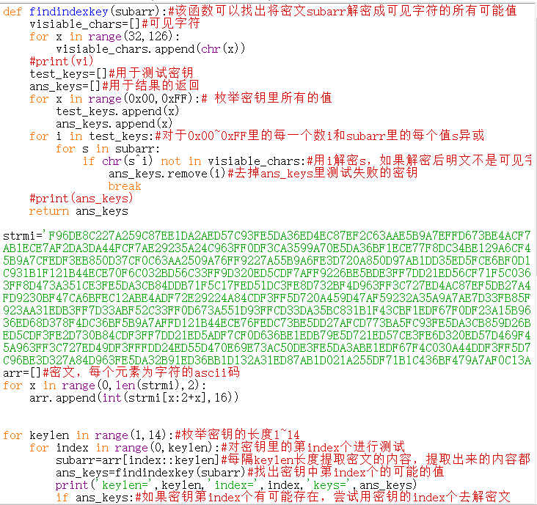

运行，得出密钥长度为7，

[[186], [31], [145], [178], [83], [205], [62]]



明文为：

Cryptography is the practice and study of techniques for, among other things, secure communication in the presence of attackers. Cryptography has been used for hundreds, if not thousands, of years, but traditional cryptosystems were designed and evaluated in a fairly ad hoc manner. For example, the Vigenere encryption scheme was thought to be secure for decades after it was invented, but we now know, and this exercise demonstrates, that it can be broken very easily.

2.重复一次一密破解

查询资料可知，每句话结尾的1E，是十六进制的等效形式0001 1110，可以猜出对应句号，并且0F对应另一个标点符号。

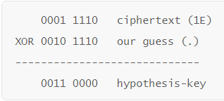

将1E与表示 . 的字符2E异或，得到密钥，再次带入0F，发现所得结果为3F(?)。

接下来利用空格进行破解，该方法利用的是字母与字母异或得到的结果为00，字母和空格异或，结果为01，所以容易区分字母和空格。

参考github代码https://github.com/riki95/Many-Time-Pad-Cracker/blob/master/cracker.py

运行代码，得到结论

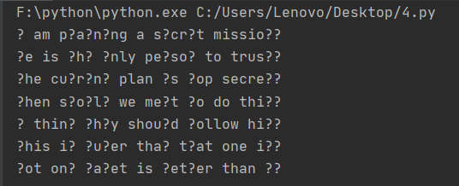

进行猜测，可以得到密文：

I am planning a secret mission

He is the only person to trust

The current plan is top secret

When should we meet to do this

I think they should follow him

This is purer than that one is

Not one cadet is better than I